Department of Transportation: New 511PA mobile application puts traveler information in drivers’ hands.
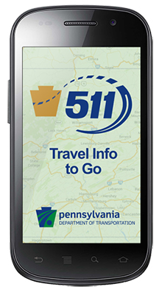
Text of May 5, 2014 press release.
PA 511 FAQ
Harrisburg – People traveling through Pennsylvania can now get better traffic information before and during a trip with PennDOT’s new, free 511PA mobile application.
The application, available for iPhone and Android devices, provides hands-free and eyes-free travel alerts for the nearly 40,000 miles of road that PennDOT maintains, the Pennsylvania Turnpike and select New Jersey and West Virginia roadways. Users can also check the application before they travel to view traffic speeds, cameras and travel alerts.
“Our mission is to provide better mobility in Pennsylvania, and that includes making sure that our customers are well informed for their travel plans,” PennDOT Secretary Barry J. Schoch said. “This application helps our customers have the most current travel information available before and during their trip.”
Application users can tailor the alerts based on event type, time between alerts, their location (with a radius of up to 500 miles), and for which direction of travel the user wants to hear advisories. When activated, the hands-free and eyes-free application plays audio alerts with traffic incidents or slowdowns within the radius the user selects.
In addition to providing traveler information on the go, the application helps drivers make travel decisions before they leave by linking to the 511PA website, www.511PA.com. The site provides alerts, cameras and more for PennDOT-maintained roadways as well as the Pennsylvania Turnpike.
To download the application, visit the iTunes or Google Play stores and search for “511PA.”
In addition to the mobile application, motorists can sign up to receive personal, customizable travel alerts, or follow the statewide or regional Twitter feeds assigned to each 511PA region.
PennDOT reminds drivers to not call or look at any of 511PA’s services while driving.
Contact: Erin Waters-Trasatt, 717-783-8800
-30-

